Task Outline
You may only use vanilla JS, HTML5, and CSS3. For each task, all relevant code should be in a single folder in a local repository. Your code should be written with industry standard best practices in mind. You will also be evaluated on your ability to understand and implement the requirements and general communication. If a task requirement is ambiguous, you may ask questions in the form of comments or make reasonable assumptions and justify them in the commit messages. When completed both folders should be sent in a single zip or rar file. For the purposes of this task we will not accept any submission on a remote git repository.

Circular Slider
Create a custom html element for a circular slider that should roughly resemble the speedometer depicted below.

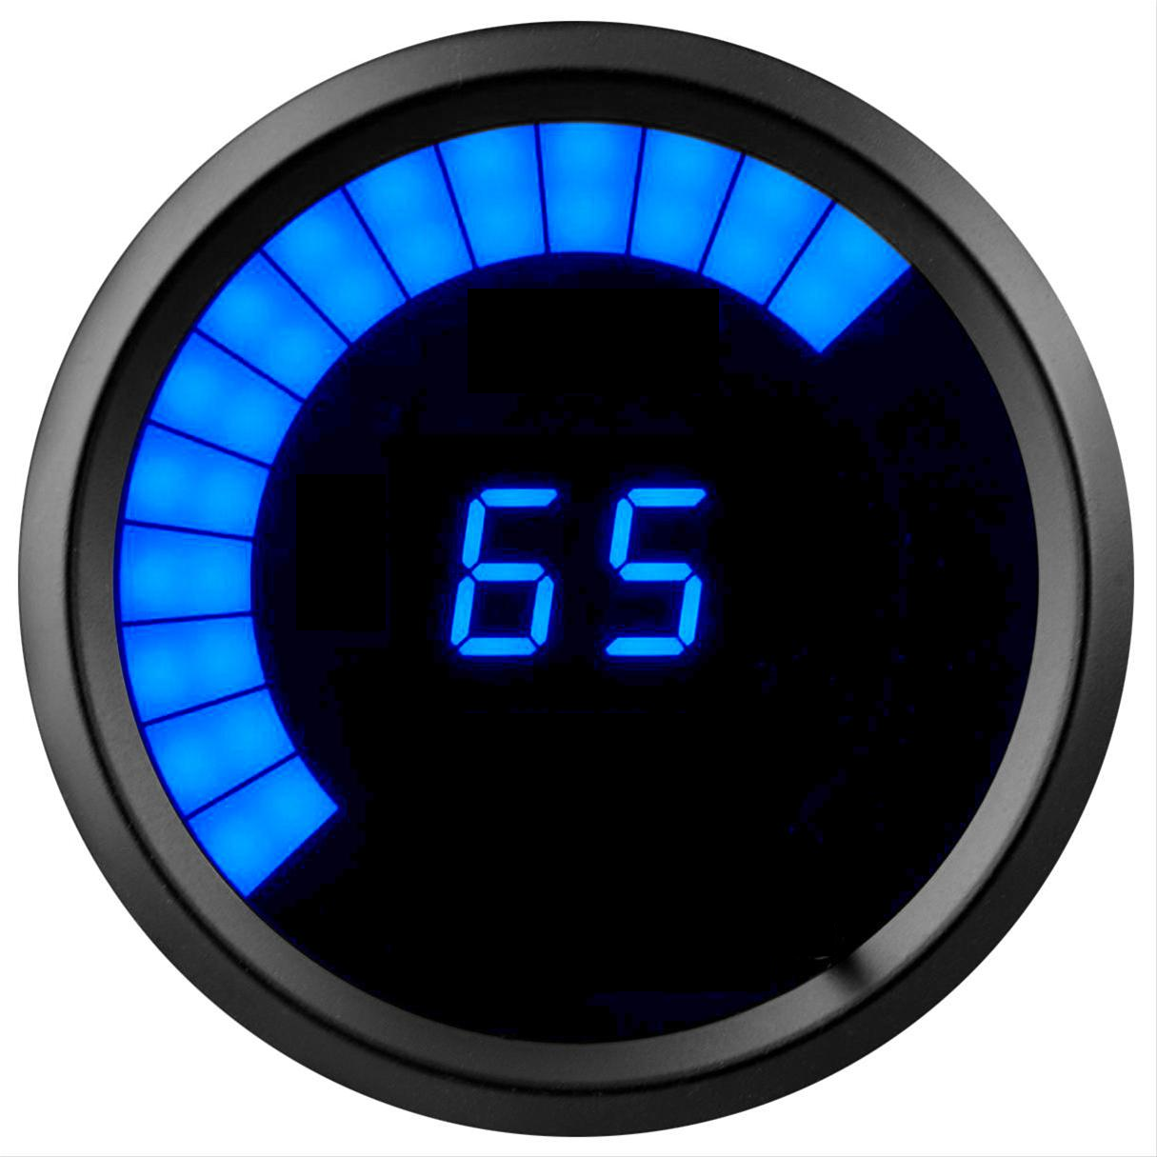
Required:
- Solid gray border.
- Progress bar type slider that grows/shrinks from the 7:30 position to the 4:30 position.
- Numerical indicator where 0 corresponds to the 7:30 position and 100 to the 4:30 position.
- Use either SVG or Canvas.
- Be 300px by 300px on page on a 1920 by 1080p screen.
- Slider color should be changed to lighter blue on mouse over.
- Slider numerical indicator should decrease when moving left on mouse down and increase when moving right.
- Size of progress bar should always correspond to the numerical indicator.
- Moving 250px to the right on mouse down should correspond to moving from 0 to 100.

Optional:
- 7 segment style display for numbers.
- Discrete bars for progress bar.
- Shadows, Reflective border, color gradients, border inset/outset.

Fade-out Timer
Create a countdown timer with pause and resume functionality.

Required:
- Fetch high resolution image and set as background:
https://stsci-opo.org/STScI-01GKMKDPJJ8SFNCHP3EVQPJJE2.png
- Fetch lorem ipsum text and display centered vertically and horizontally in a div: https://www.lipsum.com/feed/html
- Timer should not start until all external data is loaded onto DOM and ready to display.
- Timer should display remaining time in hh:mm:ss format or mm:ss format if remaining time is less than 1 hour.
- Timer background should change to red with 50% transparency when remaining time is less than 1 min.
- Timer should be inline with pause button.
- Width for the timer/pause button 150px on a 1920 by 1080p screen.
- When paused, timer should stop immediately and output current remaining time to console in milliseconds. Both the background and lorem ipsum text should be completely removed from the DOM. The body background color should fade to gray, the Timer element background should change to yellow, and the pause button should change to a resume button.
- When resumed, background image and lorem ipsum text should be loaded onto DOM and ready to display before timer resumes.
- Timer should persist even in the event that the browser is accidentally closed.

Optional:
- Smooth transitions/fade out animations.
- Configuration modal that asks user what the initial time should be set to.

